Parallel Programming Skills:
a) (76p) Foundation:
- (56p) Read this paper “Introduction to Parallel Programming and MapReduce” and
answer the following questions:
o (15p) What are the basic steps (show all steps) in building a parallel program? Show
at least one example.
- 4 steps: Decomposition, Assignment, Orchestration, Mapping.
- Example:
For a FOR loop: 1. we decompose the amount of work to be done (the total number of loop)
2. assign tasks to threads by specifying mechanism. 3. Orchestration: shared address space, message passing. 4. Mapping: decide which processes will run on same processor or particular processor.

o (5p) What is MapReduce?
- The MapReduce is a programming model and an associated implementation for processing and generating big data sets with a parallel, distributed algorithm on a cluster.

o (10p) What is map and what is reduce?
- Map takes an input pair and converts it into a set of data (intermediate key/value pairs)
- Reduce takes the output from a map as an input (intermediate key/value pairs) and combines those data into a smaller set

o (5p) Why MapReduce?
- With MapReduce, we can process unstructured data on a large scale and lets tools of data science run over distributed datasets.

o (5p) Show an example for MapReduce.
- Distributed Grep: If the map function matches a given pattern, it will emit a line. The reduce function is an identification function that only copies the provided intermediate data to the output.

o (10p) Explain in your own words how MapReduce model is executed?
- 1. Divide the input file into multiple segments
2. The master assigns tasks to workers
3. Workers assigned tasks read file shards, parse key / value pairs and pass them to map function
4. write the buffered pairs to local disk
5.reduce workers remotely read buffered data of map workers on local disk
6. Reduce wokers iteratively sort the intermediate data and pass each unique intermediate key to the reduce function. The output of the reduce function will be appended to the output file
7. Complete the map and reduce tasks and return to the user program

o (6p) List and describe three examples that are expressed as MapReduce
computations.
- Count of URL Access Frequency: The map function processes logs of web page
requests and outputs <URL, 1>. The reduce function adds together all values for the same URL and emits a <URL, total count> pair. Reverse
- Web-Link Graph: The map function outputs <target, source> pairs for each
link to a target URL found in a page named "source". The reduce function concatenates the list of all source URLs associated with a given target URL and emits the pair: <target, list(source)>.
c. Inverted Index: The map function parses each document, and emits a sequence of <word, document ID> pairs. The reduce function accepts all pairs for a given word, sorts the corresponding document IDs and emits a <word, list(document ID)> pair. The set of all output pairs forms a simple inverted index. It is easy to augment this computation to keep track of word positions.

- (6p) When do we use OpenMP, MPI and, MapReduce (Hadoop), and why?
a. OpenMP: we use it to introduce shared memory parallelism to our code. Why: it’s a very neat and powerful library to do what you otherwise might end up writing manual thread code.
b. MPI: we use it to develop parallel scientific applications. Why: they are usually tightly synchronous code and well load balanced.
c. MapReduce (Hadoop): we use MapReduce (Hadoop) when we have terabytes of data that you want to do ETL (extract, transform and load) like operations. Why: it has higher fault tolerance
- (14p) In your own words, explain what a Drug Design and DNA problem is in no more than
150 words.
- 1.generate ligands
2. simulate to find the ligand with highest score (on fitting protein and degree of shape change).
3.test the ligands

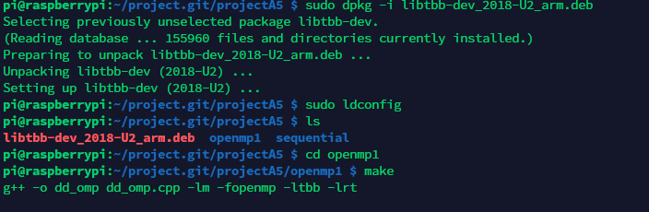
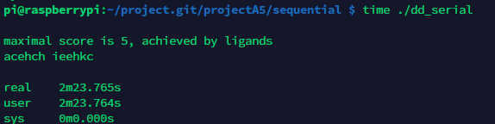

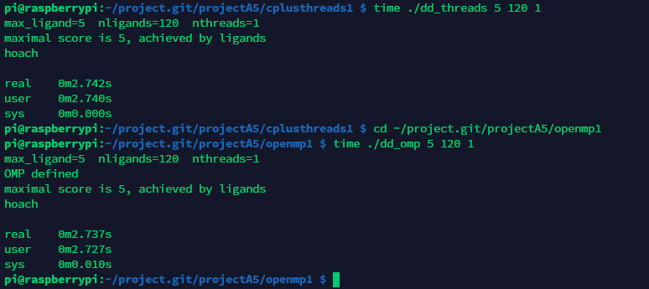
Implementation | Time (s)
dd_serial | 2m23.765s
dd_omp 1 | 0m2.737s
dd_threads 1 | 0m2.742s
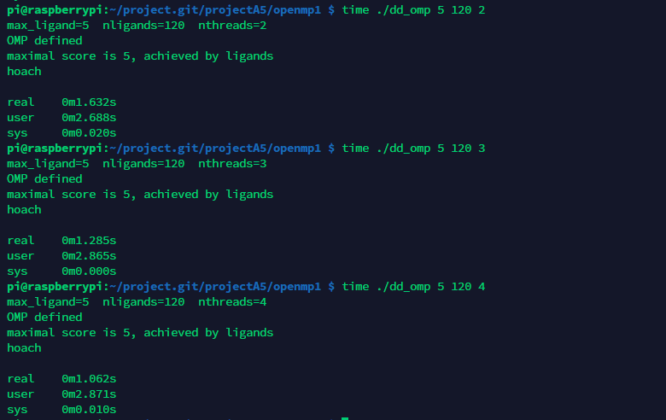
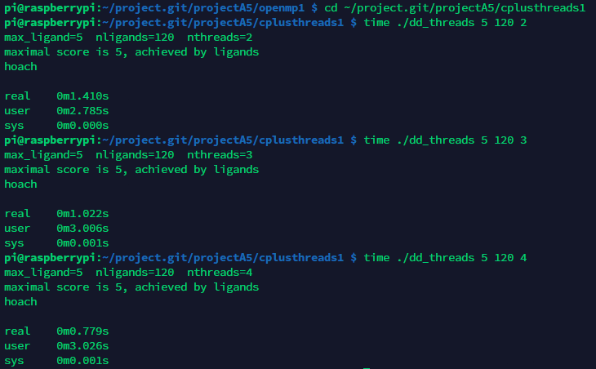
Implementation | Time (s) 2 Threads | Time (s) 3 Threads | Time (s) 4 Threads
dd_omp | 0m1.632s | 0m1.285s | 0m1.062s
dd_threads | 0m1.410s | 0m1.022s | 0m0.779 s
2.3 Discussion Questions
1. Which approach is the fastest?
C++11 is the fastest approach, but in fact it used n+1 threads (main threads).
2. Determine the number of lines in each file (use wc -l). How does the C++11
implementation compare to the OpenMP implementations?
C++11 implementation needs few codes than the OpenMP implementation.
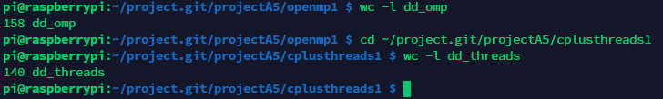
3. Increase the number of threads to 5 threads. What is the run time for each?
Run time for the OpenMP is 0m0.894s and for the C++11 is 0m0.743s.
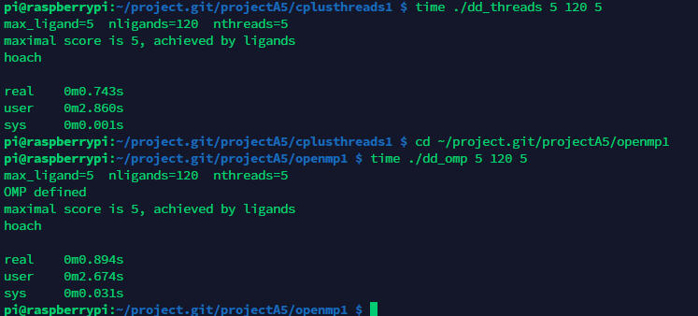
4. Increase the maximum ligand length to 7, and rerun each program. What is the run
time for each?
OpenMP:
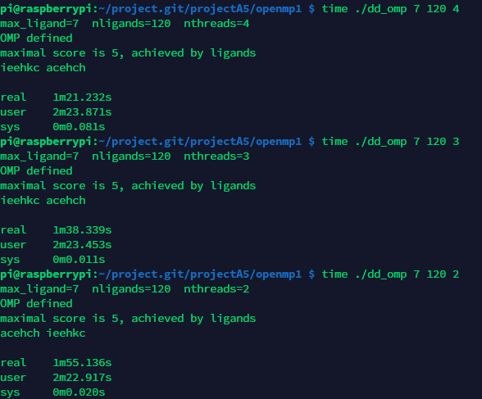
C++11:
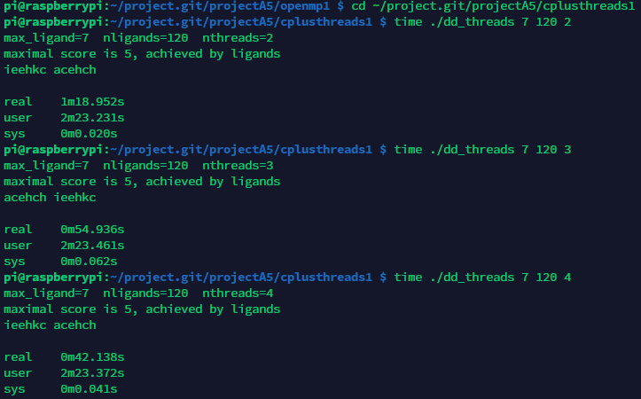
Implementation | Time (s) 2 Threads | Time (s) 3 Threads | Time (s) 4 Threads | Time (s) 5 Threads
dd_omp | 1m55.136s | 1m38.339s | 1m21.232s | 1m14.135s
dd_threads | 1m18.952s | 0m54.936s | 0m42.138s | 0m43.860s

